1. **The four types of firms**
2. **What is the most important difference between a corporation and *all* other organization​ forms?**
3. **A corporation is a legal entity separate from its owners.**
4. **A corporation is a legal entity managed by its owners.**
5. **A corporation is the only legal entity that pays taxes.**
6. **A corporation is the only legal entity that can issue bonds to raise money.**

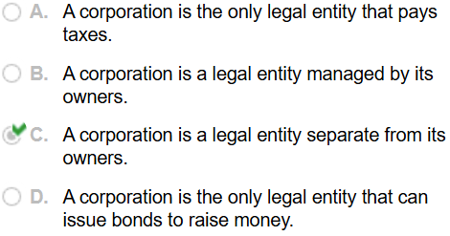

1. **What does the phrase limited liability mean in a corporate​ context?**
2. **Owners' liability is limited to the amount they invested in the firm.**
3. **Stockholders are not responsible for any encumbrances of the​ firm; in​ particular, they cannot be required to pay back any debts incurred by the firm.**
4. **Owners' liability is limited to fifty percent of the amount they invested in the firm.**
5. **Stockholders are not responsible for any encumbrances of the firm beyond fifty percent of the amount they invested in the​ firm; in​ particular, they cannot be required to pay back any debts incurred by the firm.**

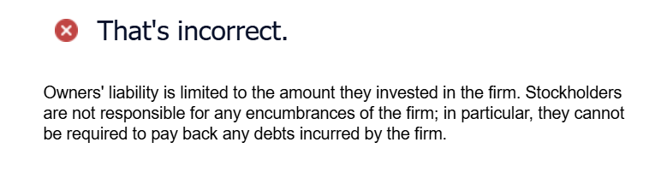

1. **Which organization forms give their owners limited​ liability?**
2. **Corporations and limited liability companies give owners limited liability.**
3. **Limited partnerships provide limited liability for the general​ partners, but not for the limited partners.**
4. **Limited partnerships provide limited liability for the limited​ partners, but not for the general partners.**

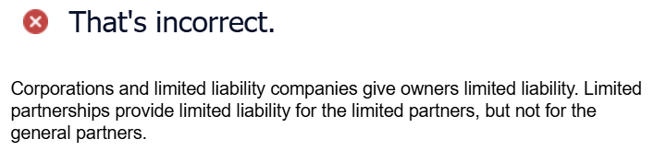

1. **What are the main advantages and disadvantages of organizing a firm as a​ corporation?**
2. **Disadvantages: Double​ taxation, separation of ownership and control.**
3. **Advantages: Limited​ liability, liquidity, infinite life.**
4. **Disadvantages: Double​ taxation, infinite life.**
5. **Advantages: Limited​ liability, liquidity, separation of ownership and control.**

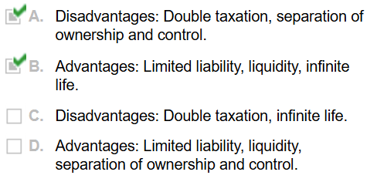

1. **Explain the difference between an S corporation and a C corporation.**

**A. S corporations must pay corporate income​ taxes; C corporations do not pay corporate taxes but must pass through the income to shareholders to whom it is taxable.**

**B. C corporations are limited to 100 shareholders and cannot have corporate or foreign stockholders.**

**C. S corporations are limited to 100 shareholders and cannot have corporate or foreign stockholders.**

**D. C corporations must pay corporate income​ taxes; S corporations do not pay corporate taxes but must pass through the income to shareholders to whom it is taxable.**

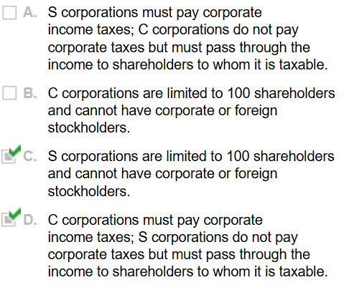

1. **You are a shareholder in a C corporation. The corporation earns ​$2.14 per share before taxes. Once it has paid​ taxes, it will distribute the rest of its earnings to you as a dividend. The corporate tax rate is 30 %​, and your personal tax rate on​ (both dividend and​ non-dividend) income is 25 %. How much is left for you after all taxes are​ paid?**

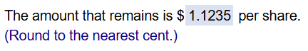

1. **You are a shareholder in an S corporation. The corporation earns ​$1.76 per share before taxes. As a pass through​ entity, you will receive ​$1.76 for each share that you own. Your marginal tax rate is 20 %. How much per share is left for you after all taxes are​ paid?**

